هيئة التعليم التقني والبحث العلمي
ال المعهد التقني / موصل
قسم الانتاج الحيواني
ماشــية لحـــــم
ســناء غازي عـــمر الخطـــاب
المدرس المساعد

Elastic Band Castration

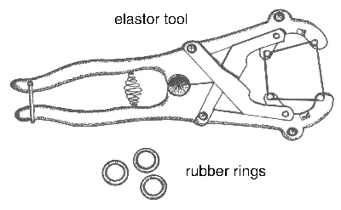


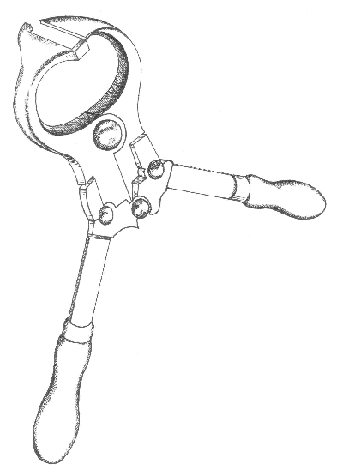

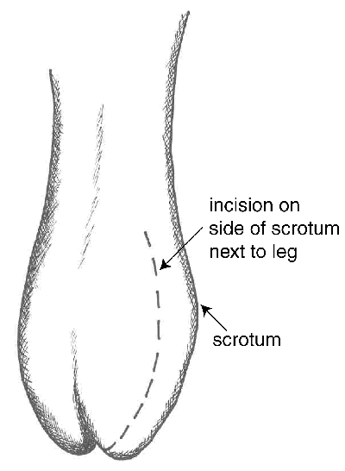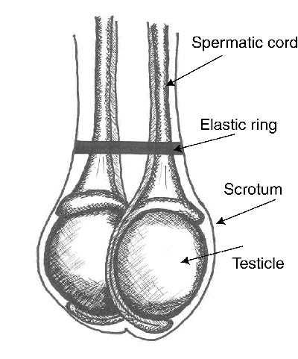

Beef Cattle Breeds
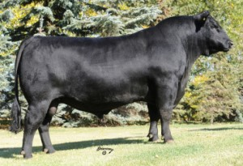

Angus:
- Imported from Scotland in 1873.
- A low maintenance breed known for calving ease and maternal characteristics.
- Natural marbling for tender and tasty beef.
- Can be black or red in color although black is dominant color.

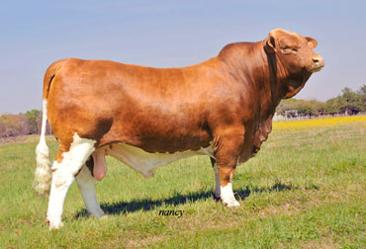

Beefmaster:
- Developed in Texas in 1930’s (Brahman-Hereford-Shorthorn cross).
- Heat, drought and insect resistant.
- Developed to thrive in the harsh climate of South Texas.
- Brownish-red is the most common color

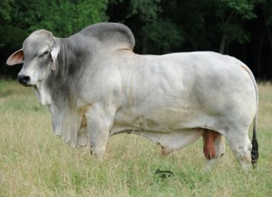
Brahman:
- Imported from India in 1854.
- Characterized by a large hump over the top of the shoulder and neck.
- Brahman have an abundance of loose skin which contributes to its ability to withstand hot weather.
- Vary in color from light gray or red to almost black. A majority of the breed are light to medium gray.

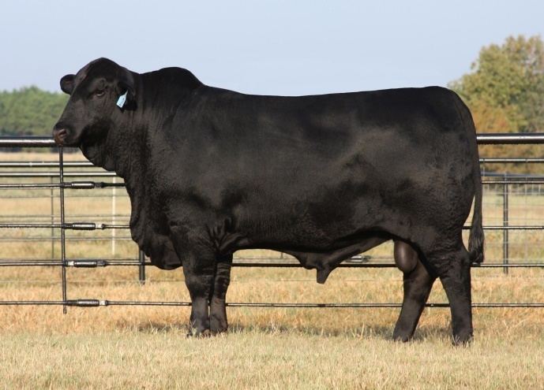
Brangus:
- Developed in 1932 in United States.
- High performers on pasture and in the feed lot.
- Proven resistant to heat and high humidity.
- Cows are good mothers.
- Brangus cattle are black or red, polled, with a sleek coat.

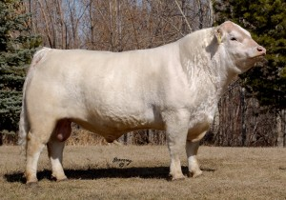
Charolais:
- Imported from France in 1936
- Tremendous muscling and conformity.
- Long bodied and good milkers.
- Known for ease of calving and cross breeding.
- The typical Charolais is white in color.

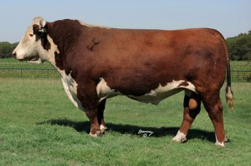

Hereford:
- Imported from England in 1817.
- Known for their grazing ability.
- Many females live and produce calves beyond 15 years of age.
- Hereford cattle are dark red , with a white face, crest, dewlap and underline.
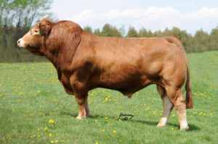

Limousin:
- Imported from France in 1971.
- Cows demonstrate high fertility, good milking ability and ease of calving.
- Limousin has built a reputation for being known as “The Carcass Breed”.
- Can be golden-red or black in color.

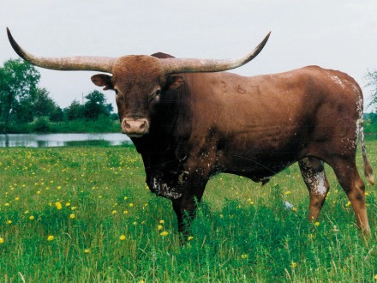

Texas Longhorn:
- Developed in Spain and brought to Mexico in 1493. Driven to Texas in 1690.
- Eats a wider range of grasses and weeds than most other cattle.
- Produces a very lean beef.
- Possesses a natural immunity to diseases and parasites.
- The most spectacularly colored cattle – so varied that no two are alike.

Beef Cattle Terms
Bovine – A ruminant mammal belonging to the genus Bos which includes cattle.
Bull – A male capable of reproduction.
Cow – Mature female that has produced a calf.
Calf – Young male or female less than one year of age.
Steer – Male that has been castrated before maturity, especially raised for beef.
Heifer – Young female over one year old that has not had a calf.

Did You Know…
The hide from one beef animal can be made into:
- 20 footballs or
- 12 basketballs or
- 18 soccerballs or
- 12 baseball gloves or
- 18 volleyballs or
- 144 baseballs
Beefmaster bull image courtesy of Emmons Ranch (2009 National Bull Championships Grand Champion Bull)
Brangus bull image courtesy of Mound Creek Ranch
Texas Longhorn bull image courtesy ofBar L Cattle CoSources: Texas Farm Bureau via txfb.org and TheCattleSite.co
Meat Productive Cuts of Meat Animals
القطع المنتجة في حيوانات اللحم

Meat animal is distinguished as a block of meat to shape up a traingle parallel partable on thick and short four feet on the contrary of milk animal which is distinguished of a traingle .It is possible ,by experience , to check good meat animal through agreed traits between animal experts ;thus these traits are ;

1-Carcass size animal presents a body of rectangular parallel .
2-Body is wide and deep .
Back and flank line is parallel . 3-
4-Body is blocky and wide plus deep in the hind quarters .
5-Pelt is not thick with short legs .
6-The animal has a muscular body with a firm fat to a certain extent .
7- The head is square and balanced upon the body with wide front . the space between the eyes is wide , too .
8-Wide brisket .
9-Wide space between the fore quarter .
10-Strong jaw .
11-The rack is short , thick and connected with the body .
12-The top of the shoulder is high , circled and blocky .
13-Straight back paralled with the flank line .
14-Wide space between the hindquarter .
15-Bones are disappeared .

Prime Cute of Young Calves Meat
القطع الممتازة في لحوم العجول الصغيرة

1-Rounds .
2-Loin .
3-Ribs .
4-Shoulder .
5-Brisket .

Other Cuts of Yong Calves Carcass
القطع الأخرى

1-Flank .
2-Plate .
Prime Cuts of Sheep Carcass
القطع الممتازة في ذبيحة الاغنام
1- Round .
2-Ribs .
3-Shoulder .
4-Shank .
Coarse Cuts of Sheep Carcass
القطع الرديئة في ذبيحة الأغنام
1-Brisket .
2-Flank .
3-Tail .
Carcas grads is measured through eye muscle area available in the animal back . Whenever fat thickness until 5 mlm or more , this means good fattening .

Cow Parts
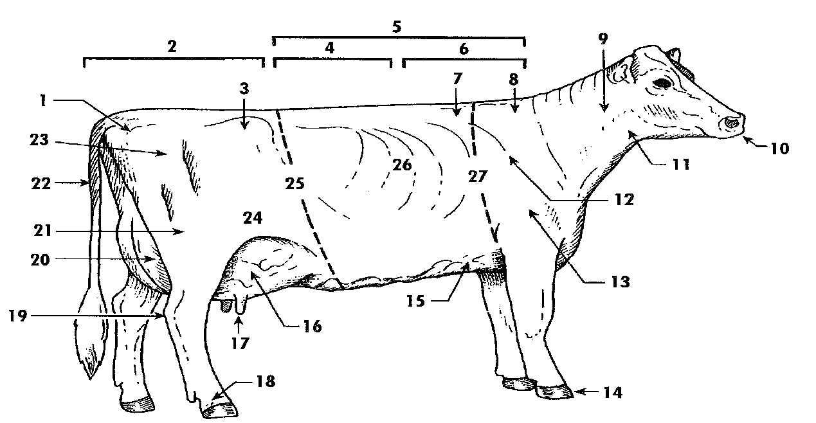
16. Fore Udder | 1. Pin Bone
17. Teat | 2. Rump
18. Pastern | 3. Hips (Hooks)
19. Hock | 4. Loin
20. Rear Udder | 5. Back
21. Thigh | 6. Chine
22. Tail | 7. Crops
23. Thurl | 8. Withers
24. Stifle | 9. Neck
25. Barrel | 10. Muzzle
26. Ribs | 11. Throat
27. Heart Girth | 12. Shoulder Blade
 | 13. Point of Shoulder
 | 14. Hoof
 | 15. Chest Floor

Meat animals farm requirements
المستلزمات الحقلية لحيوانات اللحم

Buildings (stalls):
Dry-lot and stalls are useful to protect animals from unsuitable air circumstances then to ease making daily and seasonal farm operation .

Conditions must be available on project or farm site .
1-Dry-lot or stalls must be on high floor .
2-Site must be near of water sources and transportation .
3-Building (stalls) must be opposite to the southern direction .
4-Taking into consideration design easiness and strength when building operation is done .
5-Site must be near of forage materials production and agriculture sources .
6-Farm must not be very near to a similar farm .

Conditions must be available in every building (hall) or stall for animal breeding :
1-Enough lighting and ventilation hole (windows) availability .
2-Dimensions and areas must be suited to animals number in the
building. 3-Building (stall) floor must be paved with cement .

Necessary attachments for animal stall :
1-Forage store .
2-Room for farm administration and workers.
3-farm workshop .

Tools related to animals :
1-Identification tools .
2-Hoof trimming tools .
3-Horn removing tools .
4-Castration tools and animal stabilization (fixation).
5-Hair removing tools .
6-Animal slaughtering tools skinning, cleaning and meat
Preservation
7-Different balances .

Balances :
1-small for new born claves weight and suckling calves .
2-Balances for cows and old bulls .
3-Balances for forage and concentrate weight .
4-Balances for other animal products weight .

Design types used on cow farm :
1-Fenced dry-lot with sunshades
It is the most simple types of dry-lot (pens)
It is open wide area for animal breeding
There are sunshades to protect animals of rain and hot climate .
2-Half open dry-lot .
It is a stall with two parts , the first is open and called stage , while the other is covered and surrounded of three sides . But the fourth sides is the frontage of stage and it is open . usually , stage area is doubles the area of the covered part .
3-Closed dry-lot (pens):
Dry-lot likes closed halls and have ventilation windows . This type is used in cold atmosphere (climate) countries or on born dry-lot only .

These dry-lot are costly (expensive) and need strong building materials like cement and iron .Farm operations in meat animal farms
العمليات الحقلية التي تجرى في ماشية اللحم

It is considered one of the important operations of the meat animal specially fattening animals in order to follow animal growth and food benefit of the animal . Identification is done after litter directly and the numbers are put in the records plus its weight litter and mothers weight .

Identification kinds :

1-Identification through putting numbers in the ears
Including to points :
A-plastic numbers .
B-metal numbers .
It is fixed by special instrument for each kind and it is different kinds colors

2-Identification by ear tattoo through using punching numbers plus putting black tattoo paint and its trait that identification with this kind permanent for the whole life of the animal . it is used with the white ears only because it is easy to note the number .

3-Identification by cauterization on horns .

4-Identification by caustic element the pelt specially with calves but no one advise of using this way because it spoil the pelt and reduce its worth for sale .

5-Putting chain around the neck of the animal carring the number .

6-animal painting by spray operation on the animal pelt . this way is used upon selling and buying operation between the breeders .
Note : single numbers are given to the male and dual numbers are given to the female .

Horn Removing
إزالة القرون

Sometimes this operation is done on calves farms to remove horns . This is useful because :
1-It reduces incidents of animal butting .
2-It reduces the specified area for every animal on the farm .
3-Not to hurt farm workers .

Ways of horn removing
طرق إزالة القرون

1-Using caustic soda stick or caustic potash to burn the growing top of the horns (after litter directly) . Or using electric heat stick to manage the permanent horn place in order to spoil the growing top cells of the horn .
2-Using saw or cutting wires or hook to cut the big animal horns .
3-Presently genetic method is used to have polled animals because this is the predominant trait such as polled herford and polled shorthorn .

Animal weighting
وزن الحيوانات

There are different balance on every farm of animal breeding
including balance for animal weight of different sizes and ages Animal weight operation is considered an important farm operation to know weight increase and growing grades . weight operation is done upon litter then one month age and one year of sexual puberty age. But concerning the fattening animals ,weight must be done continually to know the benefit of nutrition and there are two important weights for fattening animals:

1-primary weight.
2-Final weight.

To limit the difference between these two weights the increase amount of the fattening period which income is depended on weight in the morning before taking forage and water. Weights are done weekly or monthly and at the same time. and under the same circumstances to reduce impacts which affect the true weight value of the animal

castration
عملية خصي الحيوانات

Castration is done ( to raise rate of female hormones and to reduce hormones in blood this means to stop supplying of hormones from testicles to the body )

Advantages :-

- To raise animal ability of fat settlement .
- Animal quietness .
- Consumption raise of forage and the result is fattening animal with a quick time.

Castration : is done on young calves ready for fattening . Some changes could be done on old calves to improve meat traits before slaughtering . This operation could be done on born from one week age to many weeks by one of these methods :-

- Surgical method :
To remove testicles Surgically then to disinfect the injury . It is considered the best method of permanent animal castration .

2-Rubber rings method:
It is done by putting narrow rubber ring on the testicles top after
entering testicles in by opening tool . This ring forbids blood to pass to
testicles then to dry up and decay after a period of time .

3-Using Burdizzo clamps :-
This tool is used to bite spermatic cord and blood vessels connected with testicles so blood passing is stopped and spermatozoan transfusion is stopped from testicles to the out of the body .

- Castration by using hormones :-
Male is given female hormones to forbid the effect of male hormones and body thus to stop ability of male for fertilization . Hormones are given as powder with forage or transplant hormones tablets under pelt.

Spraying operation
عملية الرش

Spraying operation is done for two reasons :

1-Cleaning the animals .
2-Disposal of ecto parasites .

This operation is done in the hot areas by many ways either to direct water stream towards the animals by means of portable pump with attached tank of disinfected materials . Or special places for cleaning and spraying operation (on the big farms ) .
It is a narrow path for the animal passing and there are spraying pipes along its sides to direct a strong stream towards the animals . Weather must be suitable when dipping operation is done to avoid cold air streams which affect animal health

Handling and Casting
مسك وترقيد

This operation is done to check animals or cure or clean or slaughter and there are special methods of cow casting :

1-ruffs method .

2-Alternative method .

Ropes are used by these two methods and there must be three workers two of them to pull ends of the ropes while the third worker moves the head opposite of the casting direction .

Grooming
التطمير

This operation is done for animals to clean its pelt from waste and dung, Iron combs are used in this operation to comb pelt and there are advantages of that :-

1- To activate blood circulation .

2- To catalyze secretion pelt glands .

3- To make pelt clean and lighten appearance .

4- To get rid of ecto parasites.

Hoof Trimming
تقليم الأظلاف

It means removing of additional growings of the hoot to make the animal able for standing and walking in balanced way .
There are special tools and knives to trim hoof and we must be careful when this operation is done to avoid bleeding .
We must disinfect the area after removing dead growings plus waste should be removed and feet bath must be done . (i.e animal standing on place water is gathering in after adding disinfection materials to it )
This helps to wash hoof area and to remove materials in addition to kill disease causes which find a suitable place in the area between the two hoofs (hoovies) .

Animal choice
اختيار حيوانات اللحم

The following points should be concerned when choice of meat animal is done

1- free of diseases :

Inspection and choice should be done on animals before buying to be sure of not being diseased and we must sure that choice had been done before 30 days of buying otherwise choice must be repeated . we should note if there are new animals have been added to the original herd , those new animals must be isolated (separated) for 60 – 90 day to be sure of not being diseased.
The most important diseases which are connected with the productive performance and to take care of , are brucellosis in female and sterility of male
Inspection is done by veterinarian to reduce these diseases by continually choice and diseased animal isolation

2- External Appearance :

This is concerned with all meat animal special traits concerning size and shape of body plus quality traits , bones case ( situation ) .
These traits are depended on acceptance or refusal of the animal

3- Production Records :

Records are very important for the breeder specially if the herds are very big in size
In case of choice of young breeding calves , weight of weaning , shape grade at time of weaning are considered one of the important traits at time of choice , But at time of buying or choice of one year age calves , choice is done on the ground of real weight and knowing of weight ( medium ) at time of weaning .
It is noticed in records the nature of the animal relatives production .
Generally, choice of meat cattle to make herd is done as the following :

A- Big size of mothers
B- Notice of weight at weaning time and production fit.
C- old calves weight of one year age
D- Age

Animal ages of herd are done as the following :
1- Young calves ( after weaning ).
2- calves of one year age
3- calves of one – two years of age
4- old cows whether they are with their suckling calves or not
Exchange operation is done of the hear of old age cows.
Fattening
التسمين

Fattening :
Fat settlement of animal body in addition to lean meat . The main purpose of this operation is to improve tenderness , flavor and quality of meat as a response to the consumptive request .
This is done through settlement of fat grains among meat fibres . This operation is called marbling .

In addition to that fat settlement helps to improve digestion ability and nutrient value of the meat .
Domestic fattening operation is an economical operation for the purpose of getting the most big increase through raising animal weight and taking in to consideration using a cheap and available forage plus time of animal buying (suitable prices) .

Fattening Methods
طرق التسمين

There are two methods of meat cattle fattening :
1-Dry-lot fattening :
Fattening is done through this method inside simple buildings or inside fence to keep animals in and all operations are done automatically .
Nutrition is of hay good quality (legumes), in addition of concentrate rate count . Adding vitamin –A- source , salt , calcium and phosphorus as bones powder (In case of hay nutrition not legumes) .

2-Pasture fattening :
It is considered one of the cheap fattening methods but it is slow . If we compare it with dry-lot (pens) fattening , we see that animals do not achieve the same extent of musde build and body making . of dry-lot (pens) fattening .
Meat quality concerning flavor and marbling are less of animals fattened on pastures comparatively of animals fattened on dry-lot (pens)
In addition to these dry-lot (pens)need loss effort (work) and pastures fertilization are done automatically but problems of this method are shade and water .

Using methods of fattening on pastures :
الطرق المستعملة في التسمين على المراعي

1-Fattening is on pastures only without concentrate .
2-Fattening on pastures with limited quantity of concentrate .
3-Fattening is on pastures in addition to unlimited concentrate during fattening period .
4-Nutrition is on limited or unlimited quantity of concentrate when pastures being small .
5-Fattening is on pastures . At the end of period , Fattening is being on dry-lot (pens) for a short period of 60-120 days

Calves Fattening
تسمين العجول

1-Fattening is of suckling calves before weaning .
2-Calves fattening is until weaning of (3-4) moths of age .
3-Calves fattening is after weaning of (6) month of age .
4-Calves fattening is of more then one year of age of age .
5-Old calves fattening .

Calves fattening are don mainly according to age but weight is considered the main thing in the beginning and the end of calves fattening operation .
The followings are some kinds of forage . using on calves fattening according to its ages :
1-Suckling calves fattening :
Whole milk is given with some nutrient additions of concentrate for growth , (3-4) months of age .
2-Six months age :
Five kg of clover (alfalfa) is given +0,25 kg of straw +1,5 kg of concentrate . Forage quantity is increased to one year age to become (8)kg (alpha-alpha) + one kg straw +(3)kg concentrate . Quantity is increased gradually . until fattening end .
3-Calves of more than one year age are given :
(15)kg (alpha-alpha) + (2)kg straw +(3)kg concentrate and it is increased of (4)kg concentrate .
4-Fattening of old calves are given :
(30)kg (alpha-alpha)+ (3)kg straw +(5)kg concentrate . or (20)kg (alpha-alpha) +(3)kg straw +(4)kg concentrate .

Make a comparison between fattening on pastures and dry – lot fattening
اجراء مقارنة بين التسمين على المراعي و التسمين على الحظائر

Fattening on pastures | Dry-lot fattening
The most cheap fattening methods | Costly
Muscle build and body genesis are less than dry-lot fattening | Accretion of body genesis and muscle build
Flavor and marbling are less | Flavor and marbling are best
There are prolems of shade and water | It needs less effort (work)
Making of Animal Herd
تأسيس قطيع ماشية اللحم

Meat cattle herd means (animal breeding on a farm to get meat ) .
There are two main factors to succeed for a specialized agricultural project .

1-Availability of capital .
2-Workingmen (workers ) .
To accompany availability of the above – mentioned two factors , project owner must reduce the project costs in order to get a big a mount of increase and this should not affect the quality of the productive meat .

In the advanced countries , breeders take care of breeding specialized breeds for meat production such as Herford and Aberden Angus cows and Shropshire and Dorset Horn Sheep as a result of big areas of green pastures and concent rate availability . other countries take care of dual purpose (aim) animal breeding or multi aims in order to get benefit of the main produce . After the end of the period , animals are ousted of fattening period while we get benefil of bulls to make meat cattle herd .

Stages of herd making
مراحل تأسيس القطيع

After the breeder chooses the breeding kind , he must note the following points as the first stages of herd making ;

1-Division of one year age which is chosen by him for herd breeding taking into consideration workers costs .

2-Kind and amount of forage whether it is concentrate or pastures or both of them .
3-Real produce quantities on the farm which breeding is done on .

4-The available capital and tools , buildings on the farm .

5-Market case and size of meat request .

If there are pastures in certain countries , the breeding prefers old herds which include mothers and calves for the following reasons ;

1-Cows litter calves yearly even pastures circumstances (conditions) are not good .

2- There must be green pastures or farms to keep big herds because it is preferable for breeding which leads to make the healthy case of the herd better.

3- It is easy for the breeder to control the nature of his production according market request .

4- If there are different aged calves , this makes capital more circulated which results in balance between income and payments and this reduces loss as a result of meat price reduction .

5- It is easy to divide working hours of the workers during the year so the worker who pastures (20 ) twenty claves only , he can pasture (9) nine cows with them .

6- Arrangement of administration work on the farm .
7- It is easy for the breeder to produce methods of genetic fattening where the scope will be limited .

Faults of this kind of breeding
1- Increase of income is a little bit late .
2- It needs workers and administrative people of high qualifications (fitness) and experience .
3- Breeder can not change breeding nature in case of price increase and reduction for calves and old cows
4- Sterility rate is a little bit high plus mortality rate among meat cattle which increases loss as a result of diseases .
Economical Traits of Meat Animal
الصفات الاقتصادية لحيوانات اللحم

The following summarized traits are the important ones :
1-The reproductive case or fertility :
There are many factors which affect fertility (environmental factors) [keeping cow with bull until weaning] but effect of genetic factors on these traits is little , so we must take care of environmental factors as :
-Nutrition improvement .
-Disease control .
-Good administration.

2-Feed conversion efficiency (ability):
In order to improve (convert) intakes to meat , We must keep continuity of grains as a main feed source of meat production plus availability of green forage .

3-Suckling or mother efficiency (ability) :
Calve weight on parturition (Litter) is connected with animal ability on growth in its coming life . High weight on weaning is preferable and it leads to raise farm net increase .

4-Growth Rate : نسبة النمو
One of the important traits is accretion of animal growth because of its high connection with the economical case of weight increase and its relation with fixed costs such as veterinary care , buildings cost and wages of work and pasture .

5-The most important factors which affect longevity of animals are :
a-Sterility .
b-Unhealthy legs and feet
c-Dangerous eye diseases (eye cancer) .
d-Some problems of udder and mouth .

Selection as a longevity must be connected with some effects such as :

A-Healthy body genesis .
b-Information about animal bloodline .

6-Meat quality is depended on the followings :
a-Quality of meat fibers .
1-Marbliing .
2-Texture.
3-colour .
4-Firmness.

b-Puberty .
c-Fitness and similarity .

7-Body Genesis :
a-Healthy body related to the productive longevity .
b-In addition to meat muscle build ability in the body especially cuts of carcass value such as back and rounds .

The importance of buildingslaughterhouse
أهمية إنشاء المسالخ (المجازر)

1-Inspection of animals before slaughtering .
2-Isolate (keep) the suspected animals .
3-Itspection of carcass to limit diseases spreading to human being by meat .
4-Spoil uneatable meat for human being consumption .
5-Apply Islamic law on slaughtering .
6-Supplying consumer with good meat free of diseases .
7-Keeping environment health .
8-Limitation of young domestic females slaughtering .
9-Making a lot of (many) researches .
10-Making statistics and repots related to carcass .

Animal slaughtering
ذبح الحيوانات

There are factors affecting slaughtering operation and range of eatable (usable) meat for human being consumption :

1- Psychological and real stress of animals before slaughtering.
2- No forage for 24 hours before slaughtering leads to :-
A- To ease exsanguinations ( exhaustion ) and skinning operation
B- Giving bright appearance for carcass .
C- Avoid meat contamination of internal or alimentary canal contents

3- Natural veterinary inspection on wanted (intended) animal for slaughtering .
Methods of slaughtering
1- Sticking method .
2- Stunning method .
A-Immobilization by electrical gun .
B- Immobilization by hammer .
C- Electrical shock method .
D- Carbon diox id method .
This method is preferable of other method on immobilization because :-
1- It helps of animal exsanguinations ( exhaustion ) completely .
2- It dose not tire animal .
3- To forbid appearance of bloody spots .
4- To decrease loss of some nutrient compounds .
5- It is possible to preserve meat for along period of time by this method .

Slaughtering operation
عملية الذبح

1-Skinning and removing head .

2-To open abdomen by making a big split enough for a hand to go inside .

3-To cut chest by handsaw .

4-Taking out , cutting liver and dividing it .

5-To cut carcass after cleaning operation for inside and outside into two splits .

Dressing percentage (rate )
نسبة التصافي

Dressing percentage is known as :
Carcass weight percentage compared to live animal weight before slaughtering .

First case :
* 100 Dressing percentage = Carcass weight
weight animal live

second case ( the most accurate ) :
* 100 = Carcass weight Dressing percentage
weightEmpty animal

Empty animal weight = live weight subtracted digestive
system contents weight .

Affecting factors on dressing percentage :
1- Nutrition :التغذية
Dressing percentage of animal fattening on concentrate is more than 4 – 5 % of the second .
The reason is (nutrition on forage leads to raise percentage of alimentary (digestive ) canal weight compared with body weight .
Dressing percentage of origin meat cow as the following :

Weight | Dressing percentage
300kg | 54%
400kg | 56%
450kg | 57%
550kg | 59%

2- Age and live weight : الوزن الحي والعمر
Generally , live weight increase with growth old , so dressing percentage raises and this percentage increases in suckling calves externally and the reason for that is (Weight is little of alimentary) (digestive canal ) especially rumen , pelt and head weight compared with gross (total ) weight .

3-Sex : الجنس
Dressing percentage of castrated calves 56% .
Dressing percentage of uncastrated calves not more than 53%
But female calves have more dressing percentage than male .

4-Animal type : أنواع الحيوانات

Domestic cattle 50%
Origin meat cattle 60%

5-Hormones such as used hormones (tlexoestro)

6-Body genesis (conformation): تكوين الجسم
Muscle good growth resulted in dressing percentage increase .

7- Relieving s (tranquillizers) : المسكنات
Giving relieving s to animals leads to keep dressing percentage .

Records
السجلات

It is impossible of any specialized farm in animal breeding to get animal products and succeeds unless it has administration and supervision on all different production elements and correct healthy administration depending on different methods such as organization and unification of records information

Records Importance
أهمية السجلات
1-Making comparisons between cow and cattle selection of the herd so the unrequested animals will leave the herd and keeping the good ones only .

2-Study traits of the productive cows or study cow traits and this is difficult to follow accurately but by means of records .

3- To organize vaccines and healthy case of every animal and to follow stages of the sick animal treatment ( cure ) through records

4- To follow genetic improvement operations and improvement rate expected for the coming generations .

5- To know the general situation of the farm and whether direction of achieving enough income or not this is done by following the production and financial records of the situation .

6- We can ,by records , developing the farm in the future by knowing previous and present abilities and knowing the production abilities of the herd animals .

Record Kinds
أنواع السجلات

1- Administration Records:
Including payments and income record from and to the farm and what is connected with the farm buildings , Selling and buying operations of the animals and service instruments in addition to that record of workers , Technicians and people working on the farm .

2- Breeding Records:
Including male ,female and lambings records .It is possible to classify these records for every breed one by one or as a whole in one record and it is written in this record the animals numbers , date of lambing , productive and genetic traits and what is connected with the bloodline and progeny

3-Production Records :
Information related to the farm products is mentioned in these records .

4-Feeding Records :
It is specially connected with the forage given to the animals concerning forage components and the intakes forage amount and feeding needs for the stages of the animal life.

5- Health Records:
Vaccines dates against diseases are mentioned in these records and the methods of animal prevention and cure the sick animals and to decide whether these animals will be kept on the farm after cure and all related to the herd health .

There are samples of records needed by breeder of the meat production farms specially fattening farms and it is possible to unify these timetables and information in a special book or to organize as a separate card which is easy to use :-

1- Fattening calves records .
2- Mortality record of fattening calves .
3- Monthly report for growth of fattening calves .
4- Monthly report for movement of fattening calves .
fattening calves . Monthly report for5-

Meat Division
تقسيم اللحوم

Carcass is divided into four main kinds of especial carcass :
1-Young veal carcass .
2-Castrated old calves carcass .
3-Middle aged female calve carcass .
4-Pubertal bull and beef carcass .

Specifications of young veal carcass meat .
It is of suckling calve meat .
1-White colour meat
2-Less fat percentage .
3-Protein percentage increase .
4-Water percentage increase .

Meat of full growth animal
لحوم الحيوانات التامة النمو

1-Meat colour is between light rose-red to dark red
2-Increase of carcass fat percentage wherever animals grow old depending on nutrition and its quality .
3-Decrease of water and protein percentage of the origin carcass.

Sings that fix carcass type and approximate age :
1-Carcass size
2-Nature plus meat and fat colour .
3-Carcass bones .
4-High percentage of gristles is taken from young carcass
5-Bull and old cows carcass contain a lot of lymph nodes .

Beef لحوم أبقار Vealلحوم عجل
------------------ -------------------
Full growth bulls and cows Young calve carcass is
Carcass is divided as : divided as :
1-Shank . 1-Shank .
2-Chuck . 2-Shoulder .
3-Breast . 3-Ribs .
4-Plate . 4-Breat .
5-Ribs . 5-Loin .
6-Flank . 6-Round .
7-Short .loin.
8-Sir loin .
9-Rumb .
10-Round .

Scientific principles (basics) of meat division :
There are two main kinds of carcass :
1-Beef .
2-Veal .

Characteristics (points) of good carcass of cows :
1-Short legs compared with its width .
2-Neck is short .
3-Ribs are not deep and they are accurate .

But not good carcass is :
1-Legs are long compared with its width .
2-Neck is long and it has high percentage of carcass conformation .
3-Ribs are very deep and oblate .

Generally , there are four kinds of especial carcass :
1-Young calve carcass .
2-Castrated old calve carcass .
3-Middle aged female calve carcass .
4-Pubertal bull and cow carcass .
This method is the system of dividing beef carcass according to Australian system .

Old calve carcass
ذبائح العجول الكبيرة

1-Round area \rump +round .
2-Sir loin area .
3-Short loin area .
4-Ribs .
5-Chuck .
6-Shank .
7-Brisket .
8-Plate .
9-Flank .

-Head weight percentage \ live body on slaughtering 4,8-5,1 %
-Pelt weight percentage \ live body on slaughtering 4,6-6,5 %
-Full digestive system weight percentage \live body . 15,2-22,4%
-Internal parts weight percentage \for eating . 7,5-20%
But percentage of meat ,fat and bones of fattened with different age calve carcass .
1-Meat 68,7-70,5%
2-Fat 5,4-6,5%
3-Bones 23,8-25,5%
Laboratory Inspection on Meat
الفحوصات المختبرية التي تجري على اللحوم
Meat is considered as a good source for growth of all microorganisms (bacteria, enzymes, mycology and parasites).
These microorganisms cause meat deterioration and giving undesirable aroma and flavor .
Meat could be poisonous for human being on consumption
such as :
-Salmonella bacteria :
- Staphytocosus bacteria :
Uncooked meat is considered as an environment for bacteria growth because it contains all suitable elements for its growth such as food stuff , humidity and pH .
Meat deterioration increases after animal slaughter . Deterioration of meat causes endemic diseases in the animal pre-slaughter .
Worms cause these diseases and bacteria which are not important for human being but deterioration appearing post-slaughter is important especially food poisoning for human being plus bacteria and putrefaction (decay)
Animal infection of parasites causing meat contamination of parasites which pass along (transfer) to humanbeing by meat especially not well-done meat It is possible to kill these parasites on 70-75% temperature (degree) within few minutes .

Most important parasites infecting meat and could be tranfered to humanbeing .
1-Liver fluke (Worm)
2-Echinococcus granulosus .
3-Tapeworm- armed tapeworm.
There are kinds(types)of enzymes on meat surface causing stickiness (viscosity) and fat melting finally , some changes happen of color , taste and flavor of meat such as :
Torula + candida
Palatability of Meat
عوامل استساغة اللحوم

Palatability is known as the traits of meat related to its taste and these traits responding to (meeting) eye , nose and tongue .
1-External appearance of meat which is attractive rosy .
2-Texture and tenderness :
Two factors affecting tenderness :
a-Pre-slaughter factors such as age , breed and species .
b-Post-slaughter factors such as postmortem operation .

3-Juiciness .
4-Flavor and Aroma .

Evaluation of the general healthy condition of meat
تقييم الحالة الصحية العامة
The present way is to examine the possible availability (presence) of the intestinal infected bacteria :
1-Colon bacteria .
2-Feces (stool) colon bacteria .
3-Agglomerated (balled)feces bacteria .

As a summary it is possible to control microbic deterioration of meat by :
1-Depending on healthy and veterinary inspection .
2-Applying complete cleanness conditions in slaughterhouses
3-Using modern methods to forbid meat deterioration and contamination .

Nutrient value of meat
القيمة الغذائية للحم

1-Meat as a main source of protein .
2-It contains fat .
3-Carbohydrate as glycogen (animal starch).
4-Mineral elements (inorganic) in the body
5-Vitamin of meat .
Cattle is considered as an excellent source of vitamin especially vitamin B dissolved (melted) in water . Meat is a source of B12 but it is poor of v.b.c plus vitamin dissolving in fat .

How to examine meat deterioration (laboratory inspections)

كيفية الكشف عن فساد اللحوم
1-Bacteriology Inspection . a. Microscopic count . b. standard count
2-By chemical changes : example: Hydrogen sulfide and ammonium .
3-By normal (physical) changes : example :pH

